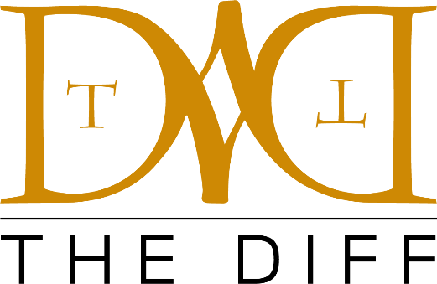

**PRESS RELEASE**

Media Contact:

The Diff Agency

nfortier@thediffagency.com

**The Diff Agency (Saranac Lake, NY Office) has hired Kimberly Beach as a Partnership Activation Coordinator.**

**Saranac Lake, NY (January 21, 2025) –** [The Diff Agency](http://www.thediffagency.com/)has hired [Kimberly Beach](https://www.linkedin.com/in/kimberly-beach/), owner of Hartman Events LLC, who will be joining the agency as a Partnership Activation Coordinator. In this role, she will oversee and activate corporate partnerships as well as event management and be based out of the Saranac Lake, NY office. Beach most recently served as Director of Operations for the Adirondack Sports Council.  In the position, she oversaw operations for several large-scale, multi-day sporting events such as the Empire State Winter Games and Adirondack Marathon and played key roles in high-profile non-recurring partnered events including the 2024 IIHF Women’s World Championship and the Lake Placid 2023 FISU World University Games. Notably, Beach secured a grant totaling $100,000 from New York State to help support the Empire State Winter Games. Prior to her time with the Adirondack Sports Council, Beach spent time with the United States Olympic & Paralympic Committee, where she coordinated SafeSport program activities to support aspiring athletes. Beach will begin her role with the organization on February 1 ([The Diff Agency](http://www.thediffagency.com/)).

**ABOUT THE DIFF AGENCY:**

The Diff is a leading sports and entertainment agency dedicated to delivering innovative solutions that meet our clients’ needs. We guide clients through the exciting world of sport and entertainment. We believe in creativity. We excel in partners.

Office Locations:

* Cleveland, OH
* Saranac Lake, NY

For more information, please visit [thediffagency.com](http://www.thediffagency.com)